A Seder Companion
By: ALHATORAH.ORG

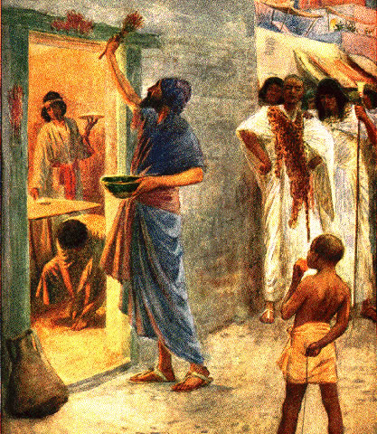

The First Passover / William Margetson

Questions, Primary Sources, and Analyses to Accompany the Seder

Dedicated with heartfelt prayers for a Refuah Shelemah for:
Yehudit bat Simcha Nachma, Wolf Leib ben Raizel

Table of Contents

Structure of the Seder 3
Structure #1: Core = Maggid + Matzah & Maror 3
Structure #2: Eating Enveloped by Liturgy 4
Kaddesh – Four Cups 4
Introduction 4
Approaches 5
Yachatz 7
Introduction 7
Approaches 7
Maggid – עֲבָדִים הָיִינוּ 10
Introduction 10
What Was Slavery Like in Egypt: A Look at the Sources 10
Maggid – מִתְּחִלָּה עוֹבְדֵי עֲבוֹדָה זָרָה הָיוּ אֲבוֹתֵינו 14
Approaches 14
Maggid – אֵלּוּ עֶשֶׂר מַכּוֹת 17
Questioning Assumptions 17
Maggid – פֶּסַח עַל שׁוּם מָה 19
Introduction 19
Approaches 20
Maggid – מַצָּה זוֹ שֶׁאָנוּ אוֹכְלִים, עַל שׁוּם מָה 23
Introduction 23
Approaches 24
Excursus: Understanding Why 28
I. "We Deserved It..." 29
II. Formative Experience 31

Structure of the Seder
https://alhatorah.org/Haggadah:Structure_of_the_Seder

The Seder is a grand banquet which, through an alternating combination of food and liturgy, celebrates and commemorates our Exodus from Egypt. As several of the Seder's most basic elements (Kaddesh, Rochtzah, Motzi, Shulchan Oreikh, Bareikh) are shared by many other meals, focusing on the components which are exclusive to it can aid in better visualizing its structure. These parts are:

- Urchatz, Karpas, Yachatz – Appetizer and other preparatory steps
- Maggid – Telling the story of the Exodus
- Matzah, Maror, Koreikh, Tzafun‎ – Eating Matzah and Maror to commemorate the Exodus and original Pesach offering
- Hallel‎ – Songs of praise and thanks

Structure #1: Core = Maggid + Matzah & Maror

A cursory glance at the list above reveals that the Seder has a dual core of Maggid and Matzah-Maror. These central obligations are really flip sides of the same coin, one auditory and the other gustatory, and together they enable the remembering and re-experiencing of the Exodus. The eating constitutes the concrete reenactment of the Paschal rite in Egypt, while telling the story through Maggid ensures that the ceremony will be a thoughtful and meaningful one.

In this structure, the inner core is preceded by a preliminary appetizer which is intended to whet both the physical and spiritual appetites, and it is then followed by a special dual Hallel which expresses gratitude for the redemption.

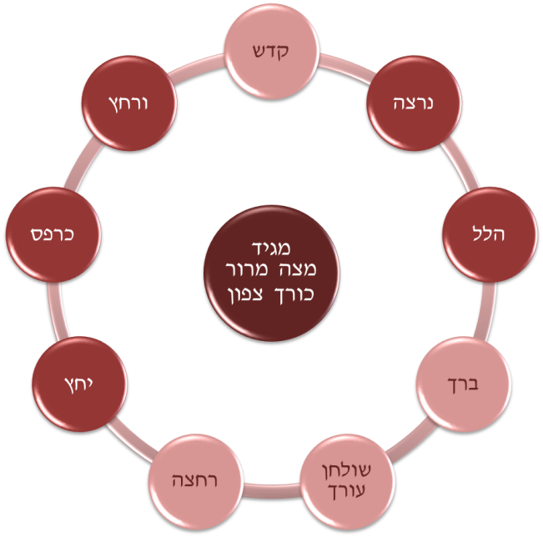

Structure #2: Eating Enveloped by Liturgy

An alternative structure is to view the eating of (the Pesach), Matzah and Maror as the central highlight of the Seder. Especially, when the Paschal sacrifice was brought, this concrete action alone ensured the ability to relive the experience of the very first Passover in Egypt. This culinary (re)experience is surrounded by two forms of liturgical praise of Hashem:

- Maggid – This section is in narrative form, precedes the eating, and focuses almost exclusively on the past.
- Hallel – This succeeding section is in poetic form and has an eye towards the future.
- According to this option also, the elements of Urchatz, Karpas, and Yachatz serve as an introduction to the main core of the Seder.

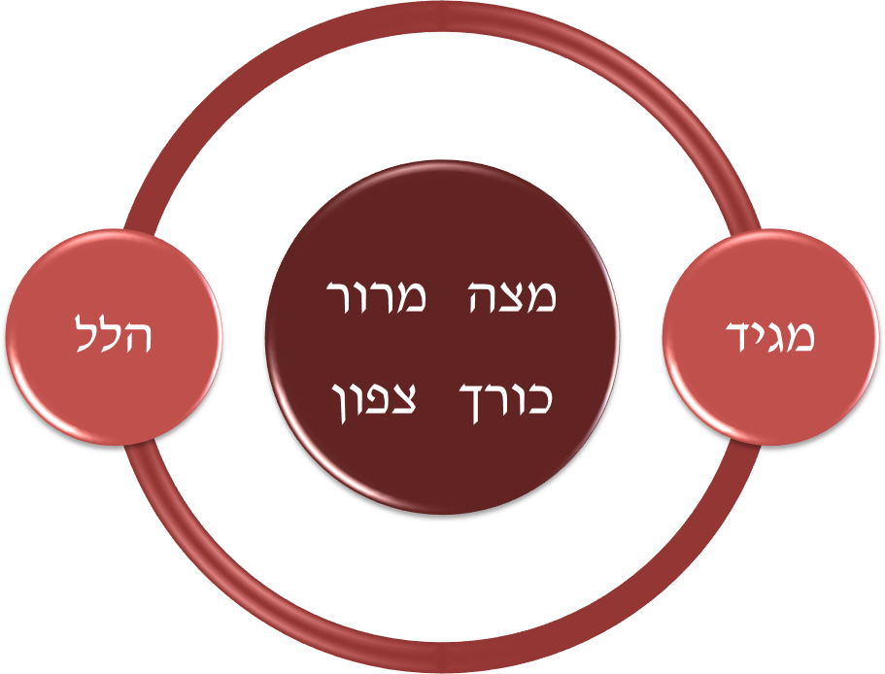

For more on this topic, see https://alhatorah.org/Haggadah:Structure_of_the_Seder

Kaddesh – Four Cups
https://alhatorah.org/Haggadah:Four_Cups

Introduction

Why Four Cups?
The obligation to drink four cups of wine at the Seder is well known and considered an integral part of the night's rituals. It is not at all clear, though, why there is such an obligation. The Torah never mentions the concept of drinking four cups, and although it is mentioned in the Mishna, no source or reasoning is presented. From where, then, did the notion derive? Why did the Rabbis enact that four cups of wine be drunk at the Seder?

Relationship to Recitations
The Mishna links each of the Four Cups to one of the four liturgical sections of the Haggadah: Kaddesh, Maggid, Birkat HaMazon, and Hallel. However, Rava in Bavli Pesachim 117b appears to imply that this connection came about only at a secondary stage:

אַרְבַּע כָּסֵי תִּיקְּנוּ רַבָּנַן דֶּרֶךְ חֵירוּת, כָּל חַד וְחַד נַעֲבֵיד בֵּיהּ מִצְוָה
The Sages instituted the drinking of four cups in the manner of freedom,
with each and every one of them we will perform a mitzvah.

What is the nature of the relationship between the Cups and their accompanying liturgies? Were the sections of the Haggadah built around the Cups, or did the Cups come merely to amplify the celebratory atmosphere of the liturgy? Or, perhaps, is the relationship a symbiotic one?

Four Additional Questions
- One mitzvah or four? Do the Four Cups constitute four separate obligations or one composite package?
- Drinking all at once – May one fulfill the obligation by drinking all four cups at once?
- Who must drink? – Must everyone drink the wine, or may the head of the household fulfill the obligation for everyone (as he might at Kiddush on Shabbat)?
- Reclining – The Cups are drunk while reclining; what does this say about their purpose?

Approaches

I. Cups of Blessing to Accompany the Liturgy

A first approach assumes that the four cups of wine serve simply as an accompaniment to the four sections of the Haggadah (Kaddesh, Maggid, Birkat HaMazon, and Hallel) which sing Hashem's praises. They do not, however, constitute their own independent obligation, but rather the liturgy is primary.

This position is expressed in Tosafot Sukkah as follows:

תוספות סוכה ל"ח.
ומסתמא לא תיקנו ד' כוסות אלא כדי לומר עליהם הלל ואגדה.

Connection to the Liturgy: A Toast Over Wine
Ba'alei HaTosafot state that the four cups were instituted only "to say over them Hallel (praises to Hashem) and the Haggadah." There is a concept, brought in the name of Rabbi Yonatan in Bavli Berakhot 35a, that when singing Hashem's praises, one should do so over wine. This might be compared to one who makes a toast, praising another with a cup of wine in hand. At the Seder we do the same. When reciting each of the four sections of praise (Kaddesh, Maggid, Birkat HaMazon, and Hallel) we accompany the recital with wine. As such, according to this approach, there is no intrinsic significance to the number four. It so happens that there are four parts of the Seder liturgy in which we "toast" Hashem's miracles, and thus there are four cups of wine.

Legal Ramifications of this Understanding
The fact that the four pieces of liturgy (rather than the cups of wine) are the focus of the mitzvah has several legal ramifications: First, each cup is considered its own individual obligation, disconnected from the other three. Second, one may not fulfill the obligation by drinking all four cups at once, as that would disconnect them from the liturgy and defeat the purpose. Third, the head of the household can discharge the obligation of the Four Cups for all those present, exactly as happens with Kiddush on Shabbat. This is possible only because the primary obligation of the Four Cups is the recital of words of praise, while the actual drinking is merely secondary. Last, while the four cups are not intrinsically related to freedom, the passages which are recited upon them revolve around redemption, leading to the requirement to drink them while reclining.

II. Demonstration of Freedom

A second approach, however, suggests that drinking four cups of wine proclaims our status as free people and is a fulfillment of the obligation to "see ourselves as if we left Egypt".

This position is adopted by R. David Bonafed (13th century, Spain):

ר' דוד בונפיד פסחים ק"ט:
ארבע כסי תקנו רבנן דרך חירות והואיל ואיכא כל חד וחד נעביד ביה מצוה...
זה לקדוש וזה לספור ההגדה וזה לברכת המזון וזה להלל.

Abundant Wine is Symbolic of Freedom: Unconnected to the Liturgy
R. David Bonafed writes that the four cups were instituted to demonstrate freedom (as drinking in abundance is an expression of happiness). As such, the basic primary obligation to drink four cups of wine is not dependent on reciting any particular liturgical passages. Linking the two is only a later development and constitutes only a secondary, more complete fulfillment of the mitzvah.

Legal Ramifications of this Understanding
Viewing the drinking of the wine (rather than the liturgy) as the core of the obligation affects several legal issues. First, according to this approach, it is only the cumulative effect of all four cups together which fulfills the obligation. Drinking a single cup or two would not be an extraordinary action and therefore would not demonstrate freedom. Second, as the liturgy is only secondary, one may fulfill one's obligation by drinking all four cups consecutively, even though this disconnects them from their proper places in the Haggadah. Third, each individual at the Seder must drink their own four cups of wine, as eating or drinking is not an action which can be performed by one person on behalf of another. Finally, one drinks the cups while reclining since both actions are meant to symbolize freedom.

Point to Ponder: Sanctifying Time

We open our Seders by saying Kiddush and sanctifying time. The very first commandment given to the nation was similarly about sanctifying time, as Hashem told the people to set Nisan as the first of the months. We often take time for granted, wasting hours, rather than ensuring that we use our days productively. As slaves in Egypt, our ancestors did not have that luxury. Their time was not their own to do with as they pleased. As such, the first thing Hashem tells us as we are freed is to recognize that time is holy and that we have an obligation to treat it as such.

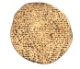

Yachatz
https://alhatorah.org/Haggadah:Yachatz

Introduction
Yachatz (the breaking of the middle Matzah before Maggid and the leaving of the larger of its pieces to be eaten as the Afikoman) is one of the most eagerly anticipated parts of the Seder, especially among many of its younger participants. The origins of this custom, however, are far from clear. In contrast to most of the other sections of the Seder which have ancient roots found already in the Mishna, there is no explicit reference to the institution of Yachatz in either Tannaitic or Amoraic literature.

What, then, is the source for the tradition, and what is the significance of the practice?

Approaches

I. Reenactment of the Exodus: Needed for Ha Lachma Anya

A first approach suggests that at Yachatz the Matzah is broken and transformed into symbols of the Exodus, introducing Ha Lachma Anya (the opening of the Maggid section of the Haggadah where one lifts the Matzah and declares, "this is the bread of affliction…").
The Avudraham (14th century, Seville) expresses this idea in his Seder HaHaggadah:

אבודרהם סדר ההגדה
ואחר אכילת שאר ירקות יבצע אחת מן השלש מצות ויתן חציה בין שתי השלמות והחצי תחת המפה זכר למשארותם צרורות בשמלותם (שמות י"ב:ל"ד) למצת אפיקומן שנאכלת באחרונה זכר לפסח שהיה נאכל על השבע. ומפני מה נהגו לפרוס המצה קודם ההגדה כדי שלא יאמר הא לחמא עניא אלא על מצה פרוסה.

This position views Yachatz and Ha Lachma Anya as two parts of a whole, a type of "show and tell," where the enslavement is depicted through both visuals and verbal accompaniments. Breaking the Matzah transforms a whole loaf into "poor man's bread," so that as we recite, "this is the bread of the poor", a concrete symbol of those words is present on the table. This act of displaying symbols of the oppression is accompanied by one of concealing, as we take the bigger piece of Matzah and wrap it. This second act recalls how the Israelites left Egypt with their dough wrapped in cloth ("מִשְׁאֲרֹתָם צְרֻרֹת בְּשִׂמְלֹתָם עַל שִׁכְמָם"). Yachatz, thus, manages to recount both the enslavement and the redemption.

II. Preparation for Eating: Needed for Motzi Matzah

A second approach suggests that Yachatz is utilitarian in nature, needed so that when one makes the blessing of HaMotzi later in the Seder, it will be over a broken loaf, symbolic of poverty.
On Shabbat or Yom Tov one normally makes the blessing of HaMotzi only on whole loaves. However, since "it is the way of the poor" to eat only part of a loaf, an exception is made at the Seder where it is customary to use a broken piece of Matzah alongside the whole one(s). This is expressed in the following source from Bavli Berakhot 39b:

Bavli Berakhot 39b  Rav Pappa said: Everyone agrees that on Passover, one places the piece inside the whole and breaks. What is the reason? “Bread of affliction” (Devarim 16:3) is written. | בבלי ברכות ל"ט:  אָמַר רַב פָּפָּא: הַכֹּל מוֹדִים בְּפֶסַח, שֶׁמַּנִּיחַ פְּרוּסָה בְּתוֹךְ שְׁלֵמָה וּבוֹצֵעַ. מַאי טַעְמָא? "לֶחֶם עוֹנִי" {דברים ט"ז:ג'} כְּתִיב.

Thus, the custom of breaking the middle Matzah is necessary for the unique nature of Motzi-Matzah which requires also a broken loaf.

Given this understanding of the custom, we might have expected "Yachatz" to take place later in the Seder, right before eating the Matzah. R. Hai Gaon (10-11th centuries, Babylonia) explains that the ruling which permits making a blessing over broken pieces applies only if the Matzah is already broken. Since it would be a sign of disrespect to take a whole loaf and break it in two immediately before making the blessing, the Matzah is broken at an earlier stage, at Yachatz.

III. Preparation for Eating: Needed for Afikoman

A third position states that breaking and hiding the Matza at this stage of the Seder is a practical measure to ensure that there will be enough Matzah for the Afikoman.

This idea is stated by Orechot Chayyim (13-14th century, Provence):

אורחות חיים, סדר ליל הפסח אות י"ב
והמנהג לחלקה קודם שיקרא ההגדה... כדי שלא יבא ויאכלנה תוך הסעודה בשוגג
ולא יהיה לו מצה משומרת באחרונה ולפיכך מצניעין אותה.

This approach suggests that the breaking of the Matzah contains no symbolic meaning or import of its own. It is a totally utilitarian measure to ensure that there is enough Matzah for the Afikoman. One hides the Matzah so that it will not be eaten by mistake. As people did not necessarily have large quantities of Matzah, there was a real concern that there would not be sufficient Matzah left over to fulfill the mitzvah of Afikoman.

IV. Ploy To Involve the Children

A final approach maintains that Yachatz is intended to provoke questions from the children participating
in the Seder, as seen in the following sources:

Tosefta Pesachim 10:9  R. Elazar says and we snatch the Matzot for the young children so that they will not go to sleep. | תוספתא פסחים י':ט'  רַבִּי לְעָזָר אָמַר: חוֹטְפִין מַצָּה לַתִּינוֹקוֹת בִּשְׁבִיל שֶׁלֹּא יִישְׁנוּ.

אורחות חיים, סדר ליל הפסח אות י"ב
וי"א כדי שיראו התינוקות וישאלו מפני מה אנו מטמינין הפת ועדיין לא אכלנו.

And some say, so that the young children will see and ask:
Why are we hiding the bread if we have not yet eaten?

This approach uniquely understands Yachatz to focus on the dual actions of splitting and concealing, rather than the resulting pieces of Matzah. Though the broken pieces are put to good use, their uses are not the source of the custom. It is the combination of the breaking and then hiding of the Matzah that elicits curiosity from the children. Upon seeing the Matzah broken, the children assume that it will be eaten, only to find it being put away! With the Matzah's concealment, they begin to question. The custom of "stealing the Afikoman" at this point in the Seder might have evolved from an understanding of R. Elazar in the Tosefta (above), that it is the children who "snatch" the Afikoman. The point is the same, to keep the youngsters awake, involved and questioning.

For further discussion, see https://alhatorah.org/Haggadah:Yachatz

Maggid – עֲבָדִים הָיִינוּ
https://alhatorah.org/Nature_of_the_Bondage

Nature of the Bondage – What Was it Like?

Introduction

When trying to imagine what the enslavement in Egypt was actually like, readers naturally look to examples of oppression and slavery in modern times and read those back into the narratives of Sefer Shemot. Some envision barracks, emaciated figures, and gulag or concentration camp conditions. Others picture plantation workers mercilessly being bought and sold from hand to hand, as occurred to slaves in the American South.

A close look at the Torah's accounts, however, may suggest that the conditions in Egypt were different. Verses in Sefer Shemot appear to indicate that the Children of Israel retained their own homes and possessions, their families remained intact, and some apparently had freedom of movement and employment. Later on in the Wilderness, the nation even nostalgically remembers their stay in Egypt, recalling the abundance of free fish and vegetables they had to eat and, at least on occasion, expressing a desire to return to Egypt! While the Israelites may be romanticizing their Egyptian experience, is it possible that their memories bore no resemblance to reality?

What Was Slavery Like in Egypt: A Look at the Sources

Monetary or Labor Tax?

Shemot 1:11 describes the first stage of the Egyptian bondage, mentioning "tax officers":

שמות א':י"א

וַיָּשִׂימוּ עָלָיו שָׂרֵי מִסִּים לְמַעַן עַנֹּתוֹ בְּסִבְלֹתָם וַיִּבֶן עָרֵי מִסְכְּנוֹת לְפַרְעֹה אֶת פִּתֹם וְאֶת רַעַמְסס.

Therefore they set tax officers over them to afflict them with their burdens.
They built storage cities for Pharaoh: Pithom and Raamses.

Is this a monetary tax or a labor quota? How does it relate to the building of storage cities described at the end of the verse? What do each of the following commentators suggest?

רלב"ג ביאור המילות שמות א'  ואחשוב שזה המס היה בתחילת הענין שהיו נותנין דבר קצוב למלך שנה בשנה, או חודש בחודש, או יום ביום – והוא היותר נכון – ואשר לא היה יכול לפרוע המס היה נפרע המלך ממנו בשיעבוד לו בבנין. ולזה תמצא שקצת ישראל לא היו עושים זאת העבודה. | רמב"ן שמות א':י"א  שם על העם מס לקחת מהם אנשים לעבודת המלך, ומינה על המס שרים מן המצריים שיקחו מהם כרצונם אנשים לפי העבודה, חליפות, חדש או יותר יהיו בבנין המלך, ושאר הימים בביתו. והשרים האלה צוו אותם שיבנו ערים לפרעה.

Ramban (13th century, Catalonia) assumes that the verses are speaking of a labor tax, while Ralbag (13th-14th century, Provence) speaks of a monetary one. According to him, only those who could not afford to pay were forced to work instead. How does each explanation affect how we think about the nature of the initial stage of the oppression? Is there any indication that really only part of the nation was at labor? Which explanation fits better with the general usage of the word "מס" in Biblical Hebrew?

Slaves to the State or to Individuals?

Shemot 1:13 appears to describe a worsening of the slave conditions:

וַיַּעֲבִדוּ מִצְרַיִם אֶת בְּנֵי יִשְׂרָאֵל בְּפָרֶךְ.
Egypt enslaved the Israelites ruthlessly (בְּפָרֶךְ).

What form did the second stage of slavery take? Does the word "מִצְרַיִם" refer to the Egyptian king or to the entire Egyptian nation? What do the following two sources suggest?

רמב"ן שמות א':י"א-י"ד  וכאשר ראו שלא יזיק זה לעם קצו בחייהם מפניהם, וגזרו שיעבידו כל מצרים את העם, וכל איש מצרי שיצטרך בעבודה ימשול לקחת מהם אנשים שיעשו עבודתו, וזה טעם: ויעבידו מצרים את בני ישראל בפרך. | מכילתא דרבי ישמעאל שמות כ':ב'  אֲשֶׁר הוֹצֵאתִיךָ מֵאֶרֶץ מִצְרַיִם מִבֵּית עֲבָדִים – עֲבָדִים לִמְלָכִים הָיוּ. אַתָּה אוֹמֵר עֲבָדִים לִמְלָכִים הָיוּ, אוֹ אֵינוֹ אֶלָּא עֲבָדִים לַעֲבָדִים הָיוּ? כְּשֶׁהוּא אוֹמֵר: "וַיִּפְדְּךָ מִבֵּית עֲבָדִים, מִיַּד פַּרְעֹה מֶלֶךְ מִצְרָיִם" (דברים ז':י'), עֲבָדִים לַמְּלָכִים הָיוּ, וְלֹא עֲבָדִים לַעֲבָדִים.

The Mekhilta (a Midrash Halakha on Sefer Shemot) assumes that the oppression in Egypt involved only state slavery (in which case, the worsening of conditions related only to the amount or type of work). Ramban (13th century, Catalonia), in contrast, assumes that though at first the nation only worked for the government, a second stage of slavery allowed for even lay Egyptians to become individual slaveholders. Which position fits better with description of slavery in the story as a whole?

How harsh were the conditions? What does the word פרך mean?

How do each of the commentators below understand the word "פרך" from Shemot 1:13, quoted above? Which best accords with the way the root is used elsewhere in Tanakh? Conceptually, how does each view the horrors of slavery?
רש"י שמות א':י"ג
בפרך – עבודה קשה המפרכת ומשברת את הגוף.

רש"ר הירש שמות א':י"ג  בפרך – הצורה היחידה הנוספת בה נמצא שורש "פרך" בתנ"ך היא: "פָּרֹכֶת". נראה ש"פרך" מציין "הפרדה". כדרך שהפרוכת הפרידה את קודש הקדשים מן ההיכל, כך הפרידו המצרים את היהודים משאר אזרחי המדינה, על ידי הפיכתם לעבדים נטולי זכויות אזרח. הם העמידו "מחיצה", כביכול, לבודד את היהודים. הוכרז על היהודים שהם שפלים מבני אדם, וממילא נבע מכך שנהגו כלפיהם ביד קשה ואכזרית. | הכתב והקבלה שמות א':י"ג  בפרך – שם פרך הונח לרש"פ על עשיית הפסק והשבתה לדבר אחד כדי להתחיל דבר שני וטעמו כאן להפסיקו מאותה מלאכה שהוא עוסק בה כדי להתחיל מלאכה אחרת, שהוא מעבודות הקשות, שאין אדם יכול לסבול שיהיה מופסק תמיד ממלאכה שעוסק בה ולא השלימה עדיין כדי לעסוק שוב במלאכה אחרת, והוא לעבד יותר ענוי נפש ממה שיעבוד עבודה כבדה, כי עבודה כבדה מחליש רק את הגוף, והפסקה ממלאכה למלאכה מחליש גם את הנפש... ומזה הענין של פרך המורה על הפסקות דבר בשביל דבר אחר, נבנה שם פרכת.

According to Rashi (11th century, France), the word "פרך" connotes hard, back-breaking labor and the verse is emphasizing the harsh physical conditions of slavery. Others, instead, highlight the emotional toll that slavery brought. Thus, HaKetav VeHaKabbalah (19th century, Germany) suggests that the word relates to "stopping" and that the Egyptians would constantly stop the Israelites mid-way through their building projects. Never being able to feel the satisfaction of a job completed and sensing the futility of one's work was harsher on the soul than the labor was on the body. Finally, R. Hirsch (19th century, Germany) suggests that "פרך" means separation and that the verse is speaking of a policy of segregation and humiliation, in which the Israelites were declared second class citizens and treated as such.

Midrashic Portraits

פרקי דרבי אליעזר מ"ח  והיו ישראל מקוששין את הקש במדבר והיו עומסין אותו בחמוריהם ונשיהם ובניהם ובני בניהם ובנותיהם והקש של מדבר היה נוקב את עקיביהם והדם היה יוצא ומתבוסס בחמר רחל בת בנו של משותלח היתה הרה ללדת ורמסה בחומר עם בעלה ויצא הולד מתוך מעיה ונתערב בתוך החומר ועלתה צעקתה לפני כסא הכבוד ובאותה הלילה ירד מיכאל המלאך והעלהו לפני כסא הכבוד ואותו הלילה ירד הב"ה והכה בכורי מצרים שנ' ויהי בחצי הלילה וי"י הכה כל בכור. | תנחומא ויצא ט'  וַיְמָרְרוּ אֶת חַיֵּיהֶם בַּעֲבֹדָה קָשָׁה. מַהוּ וּבְכָל עֲבֹדָה בַּשָּׂדֶה, אֶלָּא לְאַחַר שֶׁהָיוּ עוֹשִׂין מְלַאכְתָּן בְּטִיט וּבִלְבֵנִים וּבָאִין לָנוּחַ לָעֶרֶב לְבָתֵּיהֶן, בָּא הַמִּצְרִי וְאוֹמֵר לוֹ: צֵא לַקֵּט לִי יָרָק מִן הַגִּנָּה, בַּקֵּעַ לִי אֶת הָעֵץ הַזֶּה, מַלֵּא לִי חָבִית זוֹ מִן הַמָּיִם. הֱוֵי, וּבְכָל עֲבֹדָה בַּשָּׂדֶה. מַהוּ אֵת כָּל עֲבֹדָתָם וְגוֹ', שֶׁהָיוּ נוֹתְנִין עֲבוֹדַת הָאִישׁ עַל הָאִשָּׁה וַעֲבוֹדַת הָאִשָּׁה עַל הָאִישׁ. אוֹמֵר לָאִישׁ, קוּם לוּשׁ וַאֲפֵה. אוֹמֵר לָאִשָּׁה, מַלְאִי חָבִית זוֹ, בַּקְּעִי הָעֵץ הַזֶּה, לְכִי לַגִּנָּה הָבִיאִי יְרָקוֹת.

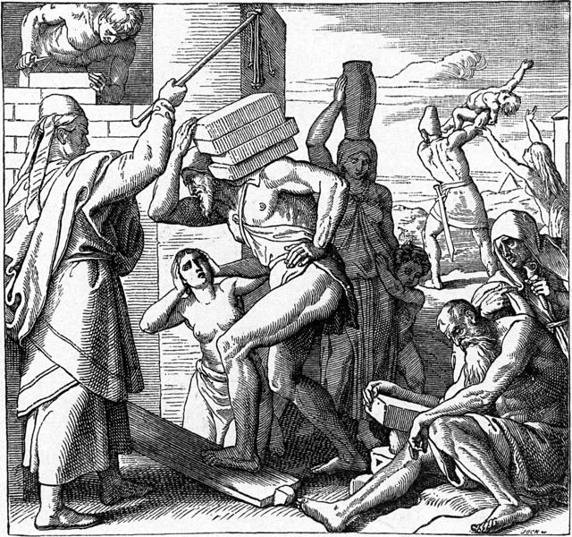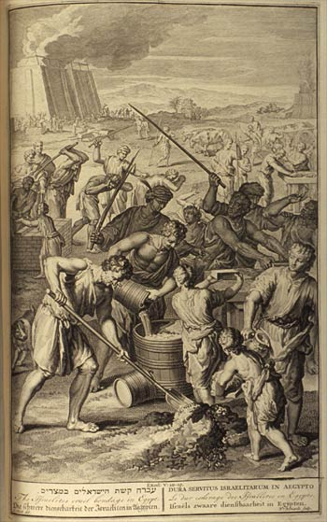

According to each source above, who was included in the decree of slavery?
Were the Israelites slaves to individuals or to the State? What were some of the horrors of slavery?
How do the depictions compare to those in Sefer Shemot?

Comparing Slavery Narratives

How did the conditions of the Israelites in Egypt compare to those of slaves in the American South?

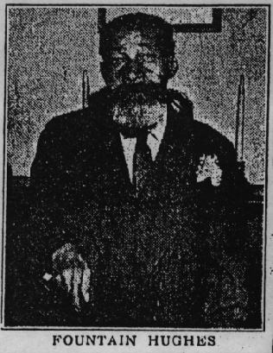
Colored people didn' have no beds when they was slaves. We always slep' on the floor… Didn' allow you to look at no book… Now I couldn' go from here across the street, or I couldn' go through nobody's house out I have a note, or something from my master…. But I couldn' jus' walk away like the people does now, you know. It was what they call, we were slaves. We belonged to people. [From an interview with Fountain Hughes, in The Emergence of Black English (Philadelphia: Johns Benjamins Publishing, 1991), 29-37.]
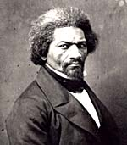
"After the valuation, then came the division. I have no language to express the… deep anxiety which were felt among the poor slaves during this time. Our fate for life was now to be decided…A single word from the white man was enough – against all our wishes, prayers and entreaties – to sunder forever the dearest friends, dearest kindred and strongest ties known to humans." (Narrative of the Life of Frederick Douglass, in I Was Born a Slave, ed. Taylor, p. 557)

Did the Children of Israel have freedom of movement? Did they have possessions or homes of their own? Were families separated? What do the verses suggest?

See: https://alhatorah.org/Nature_of_the_Bondage & https://alhatorah.org/Who_was_Enslaved_in_Egypt

Maggid – מִתְּחִלָּה עוֹבְדֵי עֲבוֹדָה זָרָה הָיוּ אֲבוֹתֵינו
https://alhatorah.org/Religious_Identity_in_Egypt

The Haggadah states that "at first" our ancestors were idolaters. To which point in history is the Haggadah referring? Though the continuation of the Haggadah implies that it is speaking of Terach and how Avraham was born into a family of idolaters, others understand the statement to be referring to the nation while in Egypt.

Thus, the Tashbetz (14th-15th century, Spain / Algiers) writes:

בגמרא אמרו: מתחיל בגנות ומסיים בשבח,
פירוש "מתחיל בגנות" – מתחילה עובדי עבודה זרה היו אבותנו במצרים

What was the religious identity of the nation while in Egypt? Did they preserve the monotheistic beliefs of the forefathers or did they assimilate into Egyptian society? Did the bondage affect either process?

Approaches

I. An Assimilated Nation: Bondage as Punishment

Tanchuma (a 6-7th century Midrash) suggests that the Israelites assimilated in Egypt:

תנחומא שמות ה'

אָמַר הַנָּבִיא: בַּה' בָּגָדוּ כִּי בָנִים זָרִים יָלָדוּ עַתָּה יֹאכְלֵם חֹדֶשׁ (הושע ה':ז'), שֶׁהָיוּ מוֹלִידִין וְלֹא מָלִין. לְלַמֶּדְךָ, כְּשֶׁמֵּת יוֹסֵף, הֵפֵרוּ בְּרִית מִילָה, אָמְרוּ נִהְיֶה כַּמִּצְרִים. כֵּיוָן שֶׁרָאָה כֵּן, הֵפֵר הַקָּדוֹשׁ בָּרוּךְ הוּא אֶת הָאַהֲבָה שֶׁהָיָה אוֹהֵב אוֹתָם, שֶׁנֶּאֱמַר: הָפַךְ לִבָּם לִשְׂנֹא עַמּוֹ (תהלים ק"ה:כ"ה). עַתָּה יֹאכְלֵם חֹדֶשׁ, חָדָשׁ כְּתִיב, עָמַד מֶלֶךְ חָדָשׁ וְחִדֵּשׁ עֲלֵיהֶן גְּזֵרוֹת קָשׁוֹת. לָכֵן כְּתִיב וַיָּקָם מֶלֶךְ חָדָשׁ אֲשֶׁר לֹא יָדַע אֶת יוֹסֵף.

Tanchuma maintains that the Israelites intentionally did not circumcise their sons in Egypt as part of a conscious attempt to assimilate. As punishment, Hashem turned the Egyptians against them, initiating the period of bondage. According to the Midrash, the people were not deserving of redemption, and in fact, many died during the Plague of Darkness. This approach might suggest that the entire purpose of the Pesach sacrifice was for the remaining people to demonstrate that they had forsaken the idolatry of Egypt and were ready to serve Hashem. This portrait fits the description in Yechezkel 20 of an idolatrous nation whom Hashem wanted to destroy in Egypt: "וְאֶת גִּלּוּלֵי מִצְרַיִם לֹא עָזָבוּ וָאֹמַר לִשְׁפֹּךְ חֲמָתִי עֲלֵיהֶם" ("Neither did they forsake the idols of Egypt; then I said I would pour out My fury upon them").

II. An Assimilated Nation: Bondage as Salvation

Netziv (19th century, Russia / Poland) agrees that the nation attempted to assimilate into Egyptian society, as demonstrated by their move out of the "shtetl" of Goshen into Egypt proper. However, in contrast to the Tanchuma, he views the ensuing enslavement not as a punishment but as a corrective:

נצי"ב שמות א':ז'
כל זה בא משום שבקשו לצאת מרצון יעקב אביהם שישבו דוקא בארץ גושן כדי שיהיו בדד ונבדל ממצרים, כמו שכתבתי בפרשת ויגש (בראשית מו,ד), אבל הם לא רצו כן. ובשמו"ר (א,ח) איתא עוד שפסקו למול מזה הטעם שאמרו נהיה כמצרים, דאחר שקבעו דירתם בקרבם מצאו טוב להם להשתוות למצרים ולא יהיו ניכרים שהמה יהודים, ומשום זה ביאר המדרש ש'הפך ה' לבם לשנוא עמו'.... וכבר ביארנו בספר בראשית (טו,יג בהרחב דבר) על הפסוק "כי גר יהיה זרעך וגו'⁠ ⁠", אשר היא הסיבה שבכל דור ודור עומדים עלינו לכלותנו בשביל שאין אנו רוצים להיות כגרים ונבדלים מן האומות.

According to Netziv, Pharoh's decrees served as Hashem's vehicle for preventing further assimilation. Though the Israelites tried to join society, Hashem ensured that the Egyptians refused their overtures, pushing them apart. Anti-Semitism was to be their salvation. In fact, Netziv suggests that Hashem's promise at the Covenant of Pieces that Abraham's descendants would always remain foreigners is what maintained Jewish identity throughout history, and is the referent of "vehi" in "והיא שעמדה לאבותינו ולנו" ("And "it" is what stood for our ancestors and ourselves"). The Jewish people's best efforts to assimilate instead engender the anti-Semitism of "in every generation they stand upon us to destroy us", through which "the Holy One blessed be He saves us from their hands" and prevents our assimilation.

III. A Monotheistic Nation: Bondage Despite Righteousness

A third approach, taken by Eliyahu Rabbah and R. Chasdai Crescas (14th century, Barcelona), suggests that the nation remained righteous in Egypt:

ר' חסדאי קרשקש אור ה׳ ג׳:א׳:ג׳:ג  ולזה היו בני ישראל סובלים עבודת המצרים הקשה, ולא היו‬ עובדים יראתם. שכבר יחשב, שאם היו ישראל שומעין להם‬ ועובדים לאלהיהם, שיקבלום בסבר פנים יפות כאחד מהם.‬ ולהיותם סובלים העניות והדלות, לבלתי היותם עובדים‬ ליראתם, די בזה ראיה, שהיו מקוים גמול נפשי... ואלמלא כן, אין‬ ספק שהיו בוחרים ההצלחה הגופנית, ולצאת מהשעבוד המפלג‬ ההוא. ואיך לא?‬‬‬‬‬‬‬‬‬‬‬‬‬‬‬‬‬‬‬‬‬‬‬‬‬‬‬‬‬‬‬‬‬‬‬‬‬‬‬‬‬‬‬‬‬‬‬‬ | אליהו רבה פרשה כ"א  כאיזה צד עבדו ישראל את אבינו שבשמים במצרים, שלא שינו את לשונם, והיו המצריים אומרים להם, למה אתם עובדים אתו, אם תעבדו אלהי מצרים יקל עבודתו מכם, משיבין ישראל ואומרים להם, שמא עזב אברהם יצחק ויעקב את אלהינו שבשמים שיעזבו בניהן אחריהן, אמרו להן, לאו, אמרו, כשם שהם לא עזבו אותו כך לא נעזבנו.

According to Eliyahu Rabbah and R. Chasdai Crescas, the Israelites were completely righteous and never worshiped idols in Egypt. They might suggest that Yechezkel's portrait of a sinful nation was true of only a very small minority of the people, while the vast majority maintained their faith. According to these sources the bondage was not punishment for sin but a "trial of love", meant to refine the nation and bring them closer to God. In their view, assimilation does not cause anti-Semitism. In fact the opposite is true; it often even prevents it. Had the nation acculturated they might have been accepted into Egyptian society and not suffered Pharoh's decrees. Despite this, though, the people chose to stay loyal to Hashem, forsaking physical rewards of this world for the spiritual ones of the next.

Point to Ponder:
Assimilation and Anti-Semitism

How does assimilation affect relations with the Gentile world? Does it cause persecution, as suggested by Netziv, or does it prevent it, as R. Crescas states? How might each exegete's position be influenced by events of their era?

R. Chasdai Crescas lived through the Spanish pogroms of 1391 (in which his son was martyred). He is projecting here the reality with which he was all too familiar of the religiously motivated persecution in Christian Spain. Although there is no hint that the Egyptian persecution was at all motivated by religious differences, it does seem clear that, for R. Chasdai, the Jews of Spain were reliving the Egyptian bondage. Netziv, in contrast, lived in 19th century Russia-Poland, witnessing both increasing assimilation of European Jewry and, simultaneously, increasing anti-Semitism and pogroms.

For elaboration, see https://alhatorah.org/Religious_Identity_in_Egypt
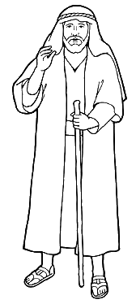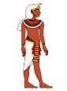

Maggid – אֵלּוּ עֶשֶׂר מַכּוֹת

Questioning Assumptions

I. Were there really ten Plagues?

https://alhatorah.org/How_Many_Plagues_Were_There

How many Plagues were there? Perhaps surprisingly, the Torah never uses the number ten or the term "מַכּוֹת" to describe the miracles in Egypt. Instead it refers to them as either "אוֹתֹת וּמֹפְתִים" (signs and wonders) or "שְׁפָטִים" (judgments). The various names point to different potential purposes of the miracles. Were they intended primarily to be educative signs and wonders or punitive plagues? As far as the number, commentators have suggested anywhere from nine (blood through darkness) to twelve (including the sign of the תַנִּין and the splitting of the sea). See the opinion of R. N"H Wessely as summarized by Shadal (19th century, Italy) below:

שד"ל שמות ז':י"ז
ראיתי להזכיר כאן שטת ר' נפתלי הירץ וויזל בענין מכות מצרים: כל המכות שהביא הקב"ה על המצרים נחלקות לד' סדרים, בכל סדר שלש מכות, ואלו הן: הסדר הראשון תנין דם צפרדע, השני כנים ערוב דבר, השלישי שחין ברד ארבה, הרביעי חשך מכת בכורות וקריעת ים סוף... והנה כל א' מהסדרים האלה התחיל במופת אחד שהיה מכה קלה ובא להתרות בם שאם לא ישובו יַכֵם אח"כ במכות גדולות ממנה, והתוכחות הללו תנין, כנים, שחין וחשך ואלה הם הנקראים אותות ומופתים, כי עם היותם מופתים ומעשה נס הנה היו לאותות ולסימנים על המכות הבאות אחריהם; ובכל המכות הקדים התראה, ובאלה (תנין, כנים, וחשך) לא התרה בהן, לפי שאינן מכות, אלא תוכחות והתראות על מה שיבוא אחריהן.

According to R. N"H Wessely, there were twelve plagues, divided into four groups of three, in each of which the first less severe wonder served as a "sign" and the last two as "judgments".

II. Who was harmed by the Plagues?

https://alhatorah.org/Whom_and_Where_Did_the_Plagues_Strike

Although it is natural to assume that only the Egyptians were affected by the Plagues, only by five of the plagues is the text explicit that the Israelites were unharmed. This leads some commentators, like Ibn Ezra, (12th century, Andalusia) below, to suggest that in the plagues which make no explicit mention of distinction between the nations, the Israelites suffered as well.

אבן עזרא פירוש שני שמות ז':כ"ד

ויחפרו – רבים אמרו: כי המים היו ביד המצרי אדומים, ונתלבנו ביד ישראל. אם כן, למה לא נכתב זה הפלא בתורה. ולפי דעתי: כי מכת הדם והצפרדעים והכנים היתה כוללת המצרים והעברים, כי אחרי הכתוב נרדף. ואלה שלש מעט הזיקו, רק מכת הערוב שהיה קשה, הפריש השם בין המצריים ובין העברים. וככה מכת הדבר והברד בעבור מקניהם. ולא בשחין, ולא בארבה, כי הם יוצאים ממצרים.

What might motivate this stance? How does this approach affect our understanding of the purpose of the Plagues or of the relative roles of the natural and supernatural in the story?

III. How Deadly? The Plague of "צפרדע"

https://alhatorah.org/Dictionary:%D7%A6%D6%B0%D7%A4%D6%B7%D7%A8%D6%B0%D7%93%D6%B5%D6%BC%D7%A2%D6%B7

The word "צְפַרְדֵּעַ" appears in only three places in Tanakh: Shemot 7:26 – 8:11, Tehillim 78:45, and Tehillim 105:30. As all three chapters speak of the same plague that was visited upon the Egyptians, the word is a virtual hapax legomenon, making it difficult to determine its meaning. What two opinions does Ibn Ezra bring?

אבן עזרא פירוש שני שמות ז'
והמפרשים נחלקו במלת צפרדעים, ורבים אמרו: שהוא מין דג ימצא במצרים, יקרא בלשון ערבי אלתמסח, והוא יוצא מן הנהר וחוטף בני אדם. ואחרים אמרו: כי הם הנמצאים ברובי הנהרות שמשמיעים קול, והוא הנכון בעיני.

Ibn Ezra brings both the common explanation that "צְפַרְדֵּעַ" refers to frogs as well as the possibility that they were crocodiles. How does this second possibility affect the way one views the plague?

IV. How Deadly? The Plague of "ערוב"

https://alhatorah.org/Dictionary:%D7%A2%D6%B8%D7%A8%D6%B9%D7%91

The plague of "ערוב", too, is mentioned only in the context of the signs and wonders in Egypt (Shemot 8:16-28, Tehillim 78:45, and Tehillim 105:31), making it difficult to define. What do each of the following sources say it means? What support do they bring from the verses?

ר' יונה אבן ג'נאח ספר השורשים "ערב"
ומלאו בתי מצרים את הערוב, פרשו בו חיות השדה. ואם כן הוא מיוחס אל ערבה בעבור עמדו שם, והוא בעיני מן החיות הרעות המשחיתות [כמו שנאמר ישלח בהם ערוב ויאכלם].

מעשי ה' מעשי מצרים י"ב
שלדעתי יחוייב לומר שלא היו דובים ואריות טורפים אנשים בשווקים, שאם היה כן לא יאמר על טריפת האנשים והריגתם תשחת הארץ מפני הערוב, אבל היו נחשים ועקרבים ושרפים וצפעונים והדומה להם שנכנסים לבתים, וע"כ לא אמר ובאו בביתך כמו שנאמר בצפרדעים. רק ומלאו בתיך וגם האדמה אשר הם עליה, ר"ל העפר אשר הבתים עליו, שאם היו אריות ודובים ומלאה הארץ לא היו משאירים להם שריד ופליט.

שד"ל שמות ח':י"ז
ועקילס ואחריו היירונימוס תרגמו עירוב של כל מיני זבובים, זבובים ממינים הרבה (ראזנמילר), והדעת הזאת האחרונה קרובה בעיני, כי לא יובן איך תבאנה החיות בבתים ולא יוכל לסגור הפתחים בפניהם.

Ibn Janach (11th century, Andalusia) declares that this was a plague of wild animals, called "ערוב" as they came from the barren "Aravah". Maasei Hashem (16th century) and Shadal (19th century, Italy) question this approach from the fact that the "ערוב" are said to have entered the Egyptian's homes, which should have been possible to prevent were they large beasts. Maasei Hashem, thus, suggests that they were a mixture of snakes and scorpions, while Shadal (following earlier sources), posits that they were some type of insect, perhaps mosquitoes or biting flies.

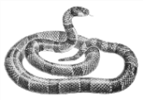

Maggid – פֶּסַח עַל שׁוּם מָה
http://alhatorah.org/Purpose_of_the_Pesach

Introduction

Shemot Chapter 12 discusses how the nation is commanded to take a lamb, smear its blood on their doorposts, and eat it roasted with Matzot and bitter herbs. What was the purpose of the ceremony?
At first glance, the answer seems obvious: Hashem directed the Israelites to apply the blood of the Pesach to their doorposts so that they would be spared during the Plague of the Firstborn. As He says:

Shemot 12:13  And the blood will be a sign for you on the houses where you are, and when I see the blood I will pass over you, and no plague will come upon you, to destroy you (לְמַשְׁחִית) as I smite the land of Egypt. | שמות י"ב:י"ג  וְהָיָה הַדָּם לָכֶם לְאֹת עַל הַבָּתִּים אֲשֶׁר אַתֶּם שָׁם וְרָאִיתִי אֶת הַדָּם וּפָסַחְתִּי עֲלֵכֶם וְלֹא יִהְיֶה בָכֶם נֶגֶף לְמַשְׁחִית בְּהַכֹּתִי בְּאֶרֶץ מִצְרָיִם.

From a theological perspective, though, this explanation is troubling. Why was such a sign necessary to save the nation? Could not Hashem have simply passed over the Israelite homes even without the smearing of blood? After all, he had distinguished between Egyptian and Israelites in previous plagues without any identifying sign, so why should the Plague of the Firstborn be any different? Finally, who or what is the "מַשְׁחִית" (the destroyer) from which the nation needed protection, and how does it relate to Hashem?

Though the blood smearing is the most highlighted feature of the Paschal ceremony, the ritual contained many other aspects, with detailed laws governing each stage. As such, to truly understand the purpose of the Pesach, we need to delve into these accompanying actions and their objectives as well:

- Why was the lamb taken four days before it was to be slaughtered?
- Why did the Pesach have to be eaten roasted, whole, and accompanied by Matzah and bitter herbs?
- Why was a year old lamb (or kid) chosen as the animal to be slaughtered?
- Was there any significance to eating the meat while belted, with shoes on, and staff in hand, or was this simply meant to ensure that all would be ready to depart Egypt at first opportunity?

Approaches

I. Protection Rite

A first approach views the Pesach mainly as a protective rite, aimed at warding off the evil of the "מַשְׁחִית" (destroyer). Commentators differ, though, in how they view the nature of the "מַשְׁחִית" and thus, in how they explain the necessity for such a rite.

A first possibility is brought by R"Y Bekhor Shor (12th century, France):

ר' יוסף בכור שור שמות י"ב:כ"ב
לא תצאו – פן יפגע בכם המשחית, שניתן לו רשות. וזהו שאמרו רבותינו בשעת דבר כנוס רגליך.

According to R"Y Bekhor Shor, who is the "מַשְׁחִית"? Why does he need a sign?

R"Y Bekhor Shor understands the "מַּשְׁחִית" to be a destroying angel, a Divine messenger sent to kill the Egyptians and spare the Israelites. It was he, rather than Hashem, who smote the firstborns. According to R"Y Bekhor Shor, once given permission to destroy, Hashem's messengers do not normally differentiate between good and evil, but are more sweeping in their actions, collectively destroying all. Thus, unlike Hashem, without the sign of the blood of the Paschal sacrifice, the "מַשְׁחִית" would not have distinguished between Egyptian and Israelite.

However, one might question this reading from the many verses which make it sound as if it was Hashem Himself, and not a messenger, who both smote the Egyptians and saved the Israelites. In addition, R"Y Bekhor Shor does not address the role played by the Pesach's accompanying rituals, such as the timing of the ceremony or the need to eat Matzah and Maror. This, perhaps, is what leads others to a second view of the rite:

II. Sacrifice

Several commentators view the Pesach as a sacrifice that strengthened the bond between the Children of Israel and Hashem in preparation for the Exodus, but differ regarding what type of sacrifice it was:

One possibility is brought by Tzeror HaMor (15th century, Spain / Portugal), below:

צרור המור שמות י"ב:ג'
ויקחו להם איש שה לבית אבות – הנה זה כפי הכוונה האמתית, להישירם אל המצוות בענין שהיה להם לזכות ולכפרה. לכן צוה לעשות שה תמים כמו שהוצרך לקרבן המזבח. ומן הראוי היה שיהיה זה הקרבן נעשה על המזבח ולזרוק דמו, אלא לפי שהיה ארץ טמאה, ואין ראוי לעשות בה מזבח, רצה הקב"ה לזכות את ישראל שיאכלוהו בלילה ויהיה חשוב להם כקרבן וכזבח וכן יש דין נותר כמו קרבן. וכמו שבקרבן היו זורקין דמו כן צוה כאן שיתנו מן הדם על המשקוף ועל המזוזות... וכן צוה ואכלו את הבשר צלי אש ומצות כמו שהיה הקרבן צלוי באש על המזבח ולא מבושל ולא חי כאומרו אל תאכלו ממנו נא ובשל מבושל במים. ראשו על כרעיו כמו שהיה בקרבן. והנותר ממנו, דינו כדין נותר הקרבן.

According to Tzeror HaMor, to what type of sacrifice might the Pesach have been similar?
Why was it necessary? What function does the smearing of blood play? How are the other aspects of the sacrifice (roasted meat, Matzah, Maror( understood?

Tzeror HaMor suggests that the sacrifice was similar to a Sin Offering, coming to atone for the nation's problematic behavior in Egypt. He accounts for many of its laws by enumerating the elements common to the Pesach and general sacrifices, including the slaughtering of an unblemished animal and the prohibition and burning of leftovers. The smearing of the blood was not needed by Hashem, who could on His own distinguish between Egyptian and Israelite, but was simply part of the sacrificial service, the equivalent of the sprinkling of blood that occurs during the bringing of other sacrifices. As the Israelite houses substituted for the altar, the blood was sprinkled on their doorposts.

R. D"Z Hoffmann, below, likens the Pesach to a different offering. Which does he choose?

ר' דוד צבי הופמן שמות י"ב:י"ג
אך מה היה אופיו של קרבן הפסח?... אבל הפסח צריך להיות כמו קרבן תודה, במיוחד בשביל ההצלה מן המוות במכת בכורות... ועוד, שלא כמו בפסח שצריך יהיה להביא בעתיד – אות תודה על ההצלה במצרים, הרי הפסח שזבחו במצרים היה גם קרבן שלמים וגם קרבן תפילה למען השיג את הישועה, ומשום כך נצטוו לזבחו "בין הערביים" – לפני בוא מכת בכורות. במצרים שימש הבית כמזבח, ודם הקרבן נזרק על מזוזותיו ומשקופיו.

According to R. D"Z Hoffmann (19th-20th century, Germany), the Pesach was a קרבן תודה (a thanksgiving offering), meant to express gratitude to Hashem for the nation's impending salvation. He, too, explains many of its laws in light of those of regular sacrifices. According to him, the commands to eat the Pesach roasted, with Matzah and bitter herbs, and while dressed for the journey, all relate to the haste in which the ceremony took place, and may have been intended to insure the completion of the meal before the Plague of the Firstborn, thus connecting the thanksgiving offering with the actual exodus.

This second approach has one significant flaw: it does not adequately account for Tanakh's own explanation of the need for the smearing of blood. It ignores the fact that the verses explicitly state that the blood served as a sign and that it was the reason for God's passing over of the Israelites. This leads to a third approach, one which attempts to address the weaknesses of each of the first two positions, to account for the need for the larger ceremony while still addressing how the blood served as a sign allowing Hashem to save the nation:

III. Demonstrative Act Against Idolatry

A last approach suggests that since sheep were part of the Egyptian pantheon, the slaughtering of the Pesach served to proclaim Hashem's sovereignty and His supremacy over the Egyptian deities. Thus, Ralbag (13th-14th century, Provence) views the ritual as an educative process through which the Israelites learned to reject the Egyptian idolatry that surrounded them:

רלב"ג שמות י"ב:ג',ט'
(ג) בעשור לחדש הזה – הקדים לקיחתו לשחיטתו ארבעה ימים... כדי שיחקרו בזה הענין אשר נצטוו בו באלו הארבעה ימים, באופן שתעקר מהם זאת האמונה הנפסדת, ויהיו נקיים ממנה בעת עשותם זאת המצוה... (ט) צותה התורה שיצָּלה שלם, להראות לישראל הפסד אמונת המצרים; כי הם יצלו אותו שלם, והוא האופן שיהיה ראוי יותר שיגיע ממנו כעס לאלהי מצרים, ובזה האופן יהיו נצולים.

According to Ralbag, how does each component of the rite help educate the Israelites towards belief?

Ralbag states that the sheep chosen was specifically an unblemished male because it was viewed by the Egyptians as the most respected member of the species. In killing it and, nonetheless, emerging unscathed, the nation would understand its worthlessness. The sheep was taken four days prior to its slaughtering to give the nation ample time to reflect on their new beliefs. Ralbag further proposes that since the Egyptians would normally punish by fire anyone who defied their gods, roasting the sheep whole was a further sign of disrespect and proof of the inability of the god to punish. Others note that idolaters would normally accompany their sacrifices with leavened bread and sweet substances. If so, the choice of Matzah and bitter herbs might also be a reaction to and distancing from idolatrous practices.

According to Ralbag, the smearing of the blood was the culmination of this educative process. It was meant not for Hashem or the destroyer but for the Israelites themselves, serving as a sign and proof for them ("וְהָיָה הַדָּם לָכֶם לְאֹת") that they had abandoned their beliefs in the Egyptian gods. It was this rejection of idolatry that led Hashem, when seeing the blood, to have mercy on them and not kill them during the plague. Thus, the blood was not needed by Hashem to distinguish between Israelite and Egyptian, but was needed by the Israelites as a way of distinguishing themselves and their beliefs from those of the Egyptians.

For further discussion, see http://alhatorah.org/Purpose_of_the_Pesach

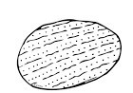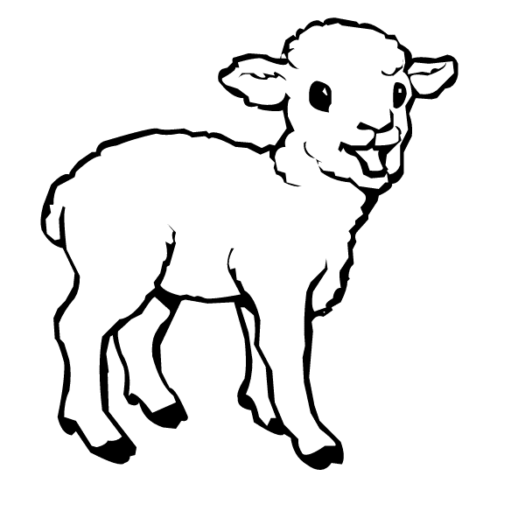

Maggid – מַצָּה זוֹ שֶׁאָנוּ אוֹכְלִים, עַל שׁוּם מָה
https://alhatorah.org/Chametz_and_Matzah_in_Pesach_Mitzrayim

Introduction

Conflicting Verses
After the Plague of the Firstborn, the Children of Israel were chased out of Egypt, leaving no time for their dough to rise:

Shemot 12:39  They baked unleavened cakes of the dough which they brought out of Egypt; for it wasn’t leavened, because they were thrust out of Egypt, and couldn’t wait, neither had they prepared for themselves any food. | שמות י"ב:ל"ט  וַיֹּאפוּ אֶת הַבָּצֵק אֲשֶׁר הוֹצִיאוּ מִמִּצְרַיִם עֻגֹת מַצּוֹת כִּי לֹא חָמֵץ כִּי גֹרְשׁוּ מִמִּצְרַיִם וְלֹא יָכְלוּ לְהִתְמַהְמֵהַּ וְגַם צֵדָה לֹא עָשׂוּ לָהֶם.

The simple reading of this verse suggests that had there been more time, the Israelites would have baked not Matzah, but rather leavened bread. However Hashem's directive of Shemot 12:15 suggests that, already before the Exodus, Hashem commanded the nation to refrain from Chametz and eat Matzah for seven days:

שִׁבְעַת יָמִים מַצּוֹת תֹּאכֵלוּ אַךְ בַּיּוֹם הָרִאשׁוֹן תַּשְׁבִּיתוּ שְּׂאֹר מִבָּתֵּיכֶם...

Seven days you shall eat unleavened bread;
even the first day you shall put away yeast out of your houses….

If so, regardless of being chased out, the people should have eaten Matzah and not bread! How can these two verses be reconciled? Did the nation refrain from Chametz due to Hashem's command or because of the speed of the redemption?

Commands and Fulfillment
Chapter 12 is replete with legal directives and Moshe's relaying of these to the nation. A close look at when each set of laws is given might bear on the questions above. In 12:1-20, Hashem speaks to Moshe about both the Pesach offering (12:2-13) and the seven day holiday of Chag HaMatzot (12:14-20). Moshe immediately relays the laws relating to the Pesach, but makes no mention of Chag HaMatzot. The latter directives are relayed only in Chapter 13:3-10, after the Exodus. This structure raises several questions:

- Relaying of laws – Why does Moshe relay only some of Hashem's directives before the Exodus, saving others for afterwards? If the laws of Chag HaMatzot were meant only for later, why does Hashem bother to tell them to Moshe beforehand? Is it possible that despite the textual silence, he nonetheless relayed them? What does this say about whether the Israelites in Egypt observed the seven day holiday and its accompanying laws of Chametz and Matzah?
- For the present or future? Finally, by only some of the laws is there explicit mention that they apply to future generations. Does this imply that these laws did not apply to the Israelites in Egypt? Or, alternatively, does it suggest that while these directives applied to both the present and future, the other laws applied only to the present?

Taken together, the above points make the reader question: which laws were kept in Egypt, which only by future generations, and which by both? What was Pesach Mitzrayim like? And finally, how does all this affect our understanding of the reason for the obligation of Matzah?

Approaches

I. Seven Day Prohibition of Chametz

The Israelites celebrated a seven day holiday in Egypt, just as they did in future generations. Chametz was prohibited for the entire week even prior to (and regardless of) their being chased out with no time for their dough to rise.

This position is taken by Tosefta Pesachim cited below:
תוספתא פסחים ח':כ"א
פֶּסַח מִצְרָיִם נוֹהֵג כָּל שִׁבְעָה, פֶּסַח דּוֹרוֹת כַּיּוֹצֵא בוֹ.

Ramban (13th century, Catalonia), also takes this position and explains how it answers many of the questions we raised in our introduction:
Hashem's commands to Moshe: one holiday or two? According to this position, the Pesach offering and the following seven day holiday of Chag HaMatzot comprise one integrated unit. Hashem commanded Moshe about both since both were to be observed in Egypt.

Which commands were relayed to the nation in Egypt? Ramban explains that even though the Torah only records Moshe relaying the commands regarding the Pesach offering, it can be assumed that he relayed all that Hashem had told him beforehand, including the laws of Chametz and Matzah. As such, even before they left Egypt, the nation was planning to eat only Matzah and not Chametz.

"They baked unleavened cakes… because they were thrust out of Egypt" – Ramban explains that the real reason that the nation baked Matzot was due to Hashem's command not to have leavened bread. This verse is only coming to explain that due to their hasty departure, they did not have time to bake Matzah in Egypt proper, but were instead forced to do so en route.

Institution of Chag HaMatzot – why? This position must explain the purpose of the original command:

- Highlight haste – Abarbanel explains that Hashem wanted to highlight the speed in which the nation left, which they would not appreciate unless they had previously been commanded to bake Matzah. He points out that even though they were never planning on baking anything other than Matzah, they did not even have time to do that. Moreover, they moved so quickly that the bread had still not risen by the time they arrived in Sukkot and had time to bake it.
- Poor man's bread – Ramban, in contrast, explains that the Matzah was supposed to commemorate the meager food that the people were given to eat as slaves in Egypt. It is not clear, however, why, at the time of the Exodus, it would be necessary for the Israelites to reenact what they lived daily.

Why seven days specifically? This position might suggest that there is no special significance to the length of the holiday. Many festivals were set to be seven days long. Abarbanel adds that had the holiday only been one day long, its significance would not be felt since often someone might go for a day without eating leavened bread.

Matzah with the Pesach offering – These sources would explain that the command to eat Matzah with the offering was part of the larger command to eat Matzah and refrain from Chametz the entire week long. The reason for both is one and the same.

Which takes precedence – eating Matzah or refraining from Chametz? Both Ramban and Abarbanel assert that throughout the week, one is permitted, but not obligated to eat Matzah. Since they maintain that the commandment did not relate to commemorating a historical seven day event of eating Matzah, this is logical. In fact, according to this approach it is possible that refraining from leavened bread is really the focus of the holiday while eating Matzah is simply the alternative left if one wants a bread-like food.

II. No Prohibition of Chametz

A second approach suggests that in Egypt, the Children of Israel did not celebrate Chag HaMatzot. Though they ate the Pesach sacrifice with Matzah, they were neither prohibited from eating Chametz, nor obligated to eat Matzah the week afterwards. The seven day holiday and accompanying obligations were instituted only later, to commemorate the haste in which they left.

This is expressed in the following Mishnah which enumerates some of the differences between Peach in Egypt and that of later years:

משנה פסחים ט':ה'
מַה בֵּין פֶּסַח מִצְרַיִם לְפֶסַח דּוֹרוֹת? פֶּסַח מִצְרַיִם מִקָּחוֹ מִבֶּעָשׂוֹר, וְטָעוּן הַזָּאָה בַאֲגֻדַּת אֵזוֹב
עַל הַמַּשְׁקוֹף וְעַל שְׁתֵּי מְזוּזוֹת, וְנֶאֱכָל בְּחִפָּזוֹן בְּלַיְלָה אֶחָד, וּפֶסַח דּוֹרוֹת נוֹהֵג כָּל שִׁבְעָה.

Ibn Ezra (12th century, Andalusia) elaborates:

אבן עזרא פירוש שני שמות י"ב:ט"ו
שבעת – טעם מצות תאכלו – זכר לאכילתכם בצאתכם ממצרים, כי לא צוו שיאכלו מצות רק הנאכלים עם הפסח לפני חצות לילה. רק שבעת ימים צוה לאכול מצות – להיות זכר לאשר קרה להם בצאתם, כי שם כתוב: כי לא חמץ (שמות י"ב:ל"ט), ואלו היו מניחין המצרים שיתמהמהו מעט היו מחמיצין עיסתם. והשבעה ימים בצאתם מצות אכלו עד שטבע פרעה ביום השביעי... והנה הזכיר על הפסח: שבעת ימים מצות תאכלו – חיוב על דרך הפשט.

Hashem's command to Moshe: one holiday or two? According to this approach, Hashem commanded Moshe about two distinct celebrations: Chag HaPesach (12:1-13) which refers to the Pesach sacrifice which was to be eaten on the fourteenth of Nisan at twilight, and Chag HaMatzot (12:14-20) which refers to the future seven day holiday in which the nation was supposed to eat Matzah and refrain from eating Chametz.

Which commands were relayed to the nation in Egypt? Moshe relayed only those commands which were immediately relevant to the nation in Egypt, those regarding the Pesach offering (12:21-27). Since Chag HaMatzot was intended only for future generations (וְחַגֹּתֶם אֹתוֹ חַג לַי"י לְדֹרֹתֵיכֶם) and the people were not obligated to celebrate it in Egypt, the nation were first told it about it only after they left.

Why no Chag HaMatzot? According to this position, the act which Chag HaMatzot was instituted to commemorate had not yet happened, so there was nothing to mark. Moreover, it would not make sense that as the nation was about to embark on a journey in the wilderness, they would be commanded to celebrate a seven day holiday, especially one in which creative work would have been prohibited.
"They baked unleavened cakes of the dough… because they were thrust out of Egypt" – This position points to this verse as proof that the nation was not prohibited from eating Chametz, as it suggests that had they not been chased out, the people were planning on baking leavened bread. Only because they had no time were they not able to.

Institution of Chag HaMatzot – Ibn Ezra explains that the seven day holiday was instituted to commemorate the fact that the nation did not even have time for their bread to rise before being chased out of Egypt, forcing them to eat Matzah.

Why seven days specifically? Ibn Ezra explains that the people were on the run until Pharoh drowned in Yam Suf seven days after the Exodus. As such, they subsisted on Matzah for the entire week. In commemoration, future generations do the same.

Which takes precedence – eating Matzah or refraining from Chametz? Ibn Ezra maintains that according to the simple sense of the verses, it is not just permissible to eat Matzah for the seven days of the holiday, but there is an obligation to do so throughout. This works with his understanding that the point of the holiday is to commemorate the nation's similar eating of Matzah.

Eating Matzah with the Pesach offering – According to this position, the reason for eating Matzah with the Pesach is unconnected to the eating of Matzah throughout the week of Chag HaMatzot. A variety of reasons are given for the command. According to some, the Pesach offering might have been a demonstration against idolatry. The Rambam asserts that idolatrous sacrifices were normally accompanied by leavened bread and honey. It is possible that to counter such practices, the Pesach was instead accompanied by Matzah and Maror. In contrast, according to R. D"Z Hoffmann, the Pesach was in essence a thanksgiving offering. If so, like all such offerings, it was brought with Matzot.

For more, see: https://alhatorah.org/Chametz_and_Matzah_in_Pesach_Mitzrayim

Point to Ponder: Matzah as Symbol

The Netziv offers a symbolic explanation for the need to eat Matzah and refrain from Chametz on Pesach. Comparing the characteristics of both foods, he notes that Chametz requires the intervention of man into nature. Left alone, a flour and water mixture will not rise. Only with the aid of man's kneading yeast into it does it become bread. Thus, leavened bread symbolizes man's desire to control nature and the pride and vanity that accompanies that. Matzah, in contrast, represents man's dependence upon nature and God; it is but a flat piece of bread, symbol of humility. Egypt saw itself as the height of civilization, subservient to none. Through the Exodus, God proved to them and the world that really all are subservient to Him; He alone is in control of nature. Pesach, thus, highlights man's dependence on God, instilling in us humility and the recognition that all stems from Him.
"וַיִּשָּׂא הָעָם אֶת בְּצֵקוֹ טֶרֶם יֶחְמָץ מִשְׁאֲרֹתָם צְרֻרֹת בְּשִׂמְלֹתָם עַל שִׁכְמָם"

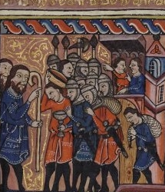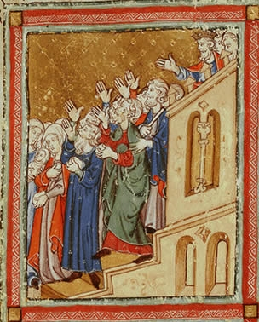
Rylands Haggadah The Golden Haggadah

Where is the Israelite's unbaked dough in each of the above depictions of the Exodus?
What does "מִשְׁאֲרֹתָם" mean? Where did they put the dough as they left?

See: https://alhatorah.org/The_Exodus_in_Art

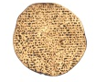

Excursus: Understanding Why

Purposes of the Egyptian Bondage – Guided Study
http://alhatorah.org/Purposes_of_the_Egyptian_Bondage

The Decree – Bereshit 15:13-14

)יג) וַיֹּאמֶר לְאַבְרָם יָדֹעַ תֵּדַע כִּי גֵר יִהְיֶה זַרְעֲךָ בְּאֶרֶץ לֹא לָהֶם וַעֲבָדוּם וְעִנּוּ אֹתָם אַרְבַּע מֵאוֹת שָׁנָה.
(יד) וְגַם אֶת הַגּוֹי אֲשֶׁר יַעֲבֹדוּ דָּן אָנֹכִי וְאַחֲרֵי כֵן יֵצְאוּ בִּרְכֻשׁ גָּדוֹל.

Already at the Covenant Between the Pieces, Avraham is told that his descendants will be exiled and enslaved for 400 years. But why was such a decree necessary? In general, how are we to understand why suffering is sometimes part of the Divine plan?

Had the Israelites had never gone down to Egypt, how would the
course of Jewish history have been different?

I. "We Deserved It..."

This approach assumes that the exile and/or bondage came as a punishment for sin. Commentators, though, disagree regarding both which sin was the ultimate cause of the suffering and who was the blameworthy party.

Source #1 – Avraham's Fault

Shemuel in Bavli Nedarim blames Avraham for displaying a lack of faith in Hashem when he requested a sign that he would inherit the land.

בבלי נדרים ל"ב.
אמר רבי אבהו אמר רבי אלעזר מפני מה נענש אברהם אבינו ונשתעבדו בניו למצרים מאתים ועשר שנים?... ושמואל אמר מפני שהפריז על מדותיו של הקב"ה שנא' {בראשית ט"ו:ח'} במה אדע כי אירשנה.

What is the advantage of attributing the sin to Avraham specifically? Why might Shemuel pick the specific incident that he does rather than any other? How is the decree of exile a fitting punishment?

It seems that this choice of sin is textually motivated. As Avraham is the one told of the exile, he must be the one at fault. Moreover, as this is the last episode that takes place before the decree of enslavement is foretold, it is natural to suggest that it is the cause. Finally, if Avraham doubted his rights to the land, then a decree of exile from the land is a fitting punishment.

Source #2 – Avraham's Fault Take Two

Ramban (13th century, Catalonia) suggests that the offense was Avraham's decision to go down to Egypt in the time of the famine, endangering Sarah as he did so.

רמב"ן בראשית י"ב:י'
ויהי רעב בארץ – הנה אברם ירד למצרים מפני רעב... והמצרים עשקו אותו חנם לקחת את אשתו, והקב"ה נקם נקמתו בנגעים גדולים, והוציאו משם במקנה בכסף ובזהב, וגם צוה עליו פרעה אנשים לשלחם. נרמז אליו כי בניו ירדו למצרים מפני רעב לגור בארץ, והמצרים ירעו להם ויקחו מהם הנשים, כאשר אמר: וכל הבת תחיון (שמות א':כ"ב), והקב"ה ינקום נקמתם בנגעים גדולים עד שיוציאום בכסף וזהב וצאן ובקר מקנה כבד מאד, והחזיקו בהם לשלחם מן הארץ. לא נפל דבר מכל מאורע האב שלא יהיה בבנים...
ודע כי אברהם אבינו חטא חטא גדול בשגגה שהביא אשתו הצדקת במכשול עון מפני פחדו פן יהרגוהו, והיה לו לבטוח באלהיו שיציל אותו ואת אשתו ואת כל אשר לו... גם יציאתו מן הארץ שנצטוה עליה מתחלה מפני הרעב עון אשר חטא, כי האלהים ברעב יפדנו ממות. ועל המעשה הזה נגזר על זרעו הגלות בארץ מצרים ביד פרעה, במקום המשפט שמה החטא.
What parallels does Ramban note between the story of Avraham in Egypt and Israel's later sojourn there?

Ramban finds support for his theory in the many parallels between the story of Avraham and Sarah in Egypt and the sojourn of the Israelites in Egypt. In both, famine leads people to Egypt where they are oppressed, but then the oppressors are punished by plague, and the victims leave with much wealth. Ramban, like Shemuel in the Bavli, views the decree as a measure for measure punishment. Avraham did not have sufficient faith to stay put in the Promised Land, so later his descendants were to be exiled from it.

Source #3 – Yaakov's Sons Were to Blame

Abarbanel (15th century, Spain) prefers to blame the exile and bondage on the brothers' sale of Yosef.

אברבנאל בראשית ט"ו
ואומר שאם נודה שהיה גלות מצרים על חטא ועון קודם... יותר ראוי שניחסהו לשבטי בני יעקב כי הנה התורה העידה שהם חטאו חטאה גדולה בשנאתם חנם את יוסף אחיהם ובמה שהתנכלו אותו להמיתו... ובהשליכם אותו אל הבור ובמה שמכרו אותו למצרים... ולפי שהם חטאו היה משורת הדין שיקבלו ענשם ולפי שבמצרים חטאו שמכרוהו להיות עבד שם היה ראוי שילקו במצרים ויהיו עבדים שמה הם ובניהם וזרעם שנים רבות... ולפי שהשליכו את יוסף אל הבור היה מענשם שכל הבן הילוד היאורה ישליכוהו. ולפי שעל ידיהם ירד יוסף למצרים היה ראוי ג"כ שעל ידו ירדו הם לגלות מצרים.

Why might Abarbanel prefer not to cast blame on Avraham? How are the
exile and enslavement a "measure for measure" punishment?

According to Abarbanel's approach, the very people who sin are the ones who are exiled. He notes the many similarities between the stories, highlighting how the punishment fits the crime. The brothers sell Yosef into slavery in Egypt and so their descendants are enslaved in the very same place. Just as the brothers had attempted to kill Yosef by throwing him into the pit, baby boys are later thrown into the Nile. A bloodied goat helped the brothers cover up their deed, and so later, a bloody sheep, the Paschal Sacrifice, acts as atonement.

Source #4 – The Israelites Sinned in Egypt

Seforno offers a very different take than the commentators above:

ספורנו שמות הקדמה
וספר בספרו השני כי מאז החל זרע ישראל לחלל ברית אבותם במצרים, כאשר העיד יחזקאל באמרו: "וימרו בי ולא אבו לשמע אלי איש את שקוצי עיניהם לא השליכו ואת גלולי מצרים לא עזבו ואמר לשפך חמתי עליהם לכלות אפי בהם בתוך ארץ מצרים" (יחזקאל כ':ח'), היו לעבדים בפרך.
What might be the advantage of Seforno's approach over the others?
What does it still need to explain?

Seforno (16th century, Italy) suggests that the blameworthy party is neither Avraham who was foretold of the punishment, nor the brothers who were exiled, but rather the Israelites themselves who were enslaved in Egypt – in other words, the generation which sinned was also the generation which was enslaved. As evidence, he points to verses in the Book of Yechezkel which speak of the Israelites in Egypt turning to idolatry.

This entire approach, that afflictions must be punishment for sin, is a fairly common one, used by many even today to explain suffering. There are many people, though, who are uncomfortable with the concept, partially because life experience shows that even righteous people sometimes suffer despite not having sinned. This leads to a second, very different understanding of the need for the exile and bondage:

II. Formative Experience
An alternative approach suggests that the bondage was necessary as it served either to educate the Israelites or to otherwise mold them as a nation:

Source #1 – Strengthening Belief in Hashem

רלב"ג במדבר ט"ו:מ"א
רוצה לומר שכבר הוציאם מארץ מצרים באופן שיהיה להם לאלהים מצד עוצם הנפלאות שראו ישראל אז. והנה רמז עם זה בזה המאמר אל מה שביארנו בענין ברית בין הבתרים; והוא, כי אברהם כששאל אות על ירושת הארץ... שיהיה זרעו באופן מהשלמות... ובאהו המענה כי ה' יתעלה יישירם אל זה השלמות בשישימם גֵרים בארץ לא להם ובעבדות נפלא, ואחר זה יהיה דן את הגוי אשר יעבודו, ויוציאם ברכוש גדול, ובאלו הדינין והמכות אשר דן הגוי ההוא הישיר ישראל אל השלמות באופן שהיו ראויים לקבל התורה שהיה בה ה' יתעלה להם לאלהים והם לו לעם.

According to Ralbag (13th-14th century, Provence), what message was the redemption from Egypt and its accompanying miracles meant to convey?

Ralbag explains that the redemption demonstrated Hashem's power, strengthening the Israelites' belief in Hashem and preparing them to receive the Torah. The exile and bondage were merely a necessary prelude for this objective. One wonders, however, why Hashem could not have instilled belief without first subjecting the nation to such suffering.

Source #2 – Teaching Empathy

נחמה ליבוביץ, עיונים חדשים בספר שמות , עמ' 14-12
ואולם תשובה מדויקת יותר לטעם הגלות... תגלה לנו אם נעיין בתורה עצמה, באותם הפסוקים שבהם היא מזכירה את גלות מצרים ועבדות מצרים כהנמקה למצוות... בתורה מנומקות המצוות המגינות על העבד בהזכרת החוויה הממשית אשר עברה על האומה עצמה והיא חרותה על לוח לבם, חווית עבדותם והשפלתם. כן בשביתת העבד בשבת... על פי פסוקים אלה... אפשר אולי לשער, שזהו טעם גלות מצרים... שירגישו הם בבשרם מהי עבדות ומהי השפלה, ומהו היות נתון לחמס ולגזל ולשלטון האדם באדם לרע לו.

What was the main lesson to be learned from the process of enslavement according to Nechama Leibowitz (20th century, Israel)? Could this lesson not have been instilled in any other way?

Nechama Leibowitz emphasizes that the enslavement was meant to teach the Israelites an important lesson in empathy. By experiencing exile and slavery themselves, the Children of Israel learned to feel and care for the downtrodden and less fortunate members of society. She notes how the Torah references the Egyptian exile in numerous commandments which deal with social justice. Today, in fact, the Exodus has become a global symbol of liberty, justice, and human rights. However, it is difficult to say that the Torah is implying that this was the purpose of the exile and slavery, rather than a lesson that can be derived in retrospect. It would seem that empathy could have been taught in a less painful way. Moreover, it is unclear if those who have not experienced slavery firsthand and only experience it via one's national memory are more sensitive to the issue than any other.

Source # 3 – Nation Building
רש"ר הירש בראשית מ"ה
בכנען, לא הייתה משפחת יעקב נעשית לאומה. כאשר המשפחה הייתה גדלה, הם היו מתערבים ונטמעים באוכלוסיה הסובבת אותם. בכדי להיות לעם ולא להתבולל, היה עליהם לבוא אל תוך אומה אשר עצם מהותה היה מנוגד לכלל האופי היהודי ותכונותיו – אומה זו הייתה מצרים. בדומה לכך, הקנאות הדתית העיוורת שגרמה ליצירת הגטאות שימשה ככלי ביד ה' להרחיקנו מתרבות החטאים של ימי הביניים, כדי שנטפח את האושר של חיי המשפחה ואת רוח המשפחה והקהילה בתוך חוגנו הצר.... בסופו של דבר, בין הגלות הראשונה ובין הגלות האחרונה, נגרמו מקנאה ושנאת חינם. והכור המצרף של הגלות, דרך ייסורי העינוי, זיכך וטיהר את כל חלקי עמנו, ופיתח בהם תחושה של שוויון ואחווה.

According to R. Hirsch (19th century, Germany), why was the experience in Egypt vital for the formation of the Israelite nation? Why was the threat of assimilation weaker in Egypt than in Canaan? What parallels to modern history does he draw?

R. Hirsch asserts that had Yaakov's family remained in Canaan they would have been assimilated into the surrounding nations. The nation was exiled to Egypt because there the chances of assimilation were much smaller. Since the Egyptians were xenophobic and would not even eat with the Hebrews, let alone marry them, it was not as likely that the people would acculturate there. Forced to live in Goshen, they could preserve their national identity. R. Hirsch notes how later in history, ghettos continued to play the same role as Goshen, ensuring that the Jews remained distinct and did not assimilate.

R. Hirsch further views the tribulations of exile as a vehicle for not only religious growth, but also for societal and interpersonal maturation. He claims that both the Egyptian and the current exiles resulted from jealousy and class distinctions. Yaakov's preferential treatment of Yosef and the difference in status between the sons of his primary wives and those of his maidservants led to family strife. Similar sectarian divisions have plagued Judaism ever since. Anti-Semitism, though, is blind to such divisions, and it serves as the great equalizer, promoting unity and forging common experiential bonds among all Jews.

For discussion, see http://alhatorah.org/Purposes_of_the_Egyptian_Bondage

Point to Ponder: Lessons of the Holiday

What lessons can we take away from the story of the exile and redemption?
How does retelling it annually bring us closer to Hashem?
How does it help us think about and care for the disadvantaged?

!!לְשָׁנָה הַבָּאָה בִּירוּשָׁלָיִם הַבְּנוּיָה

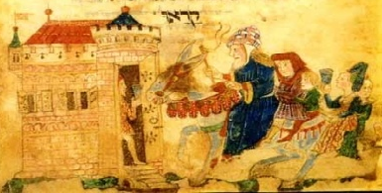

Eliyahu announcing the future redemption, Washington Haggadah

For more Haggadah resources, please visit: https://alhatorah.org/Haggadah:Home

